Google Analytics

1. Users:-

show how many users engaged with your site or app.

1. New Users:-

a visitor who, according to Google's tracking snippet, has never been to your site before and is initiating their first session on your site.\

1. Views:-

a set of specifications for tracking traffic on a single domain.

1. Sessions:-

A session initiates when a user either opens your app in the foreground or views a page or screen and no session is currently active.

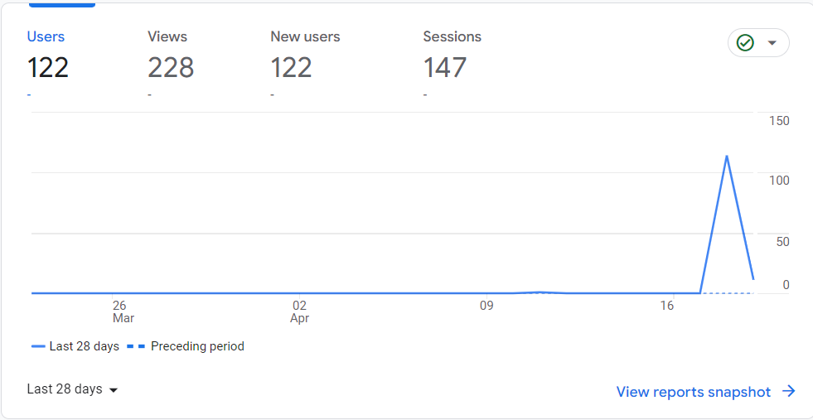

1. Organic Users:-

traffic who clicked a link on a search engine like Google or Bing.

1. Direct Users:-

traffic the source is not known.

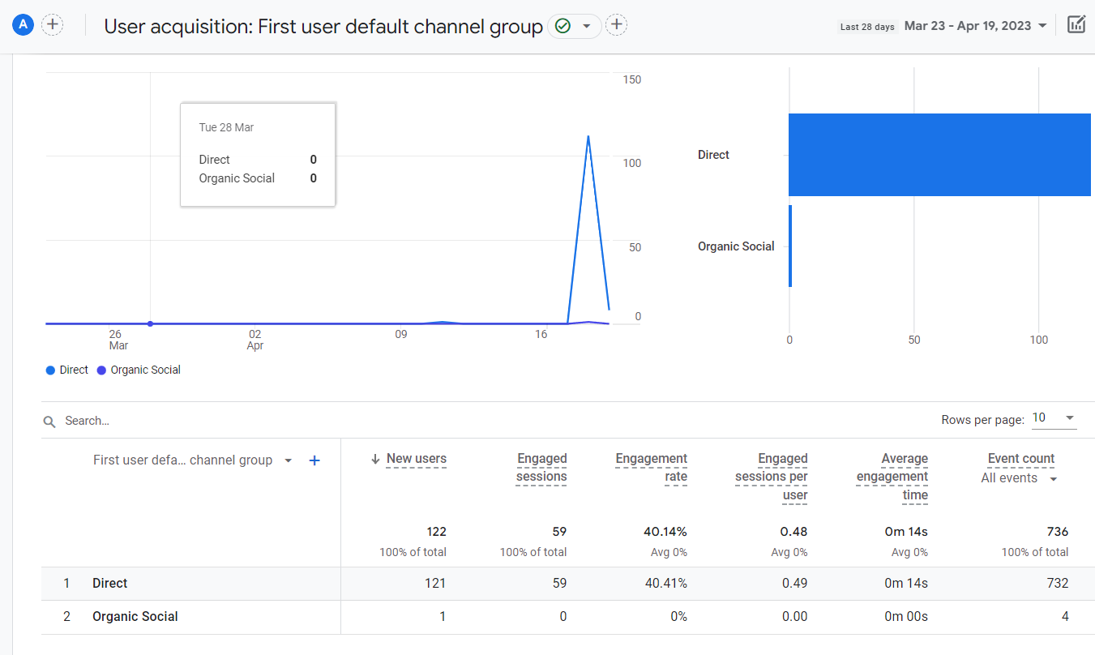

1. Traffic Acquisition:-

insights into where new sessions came from, regardless of whether the user is new or returning.

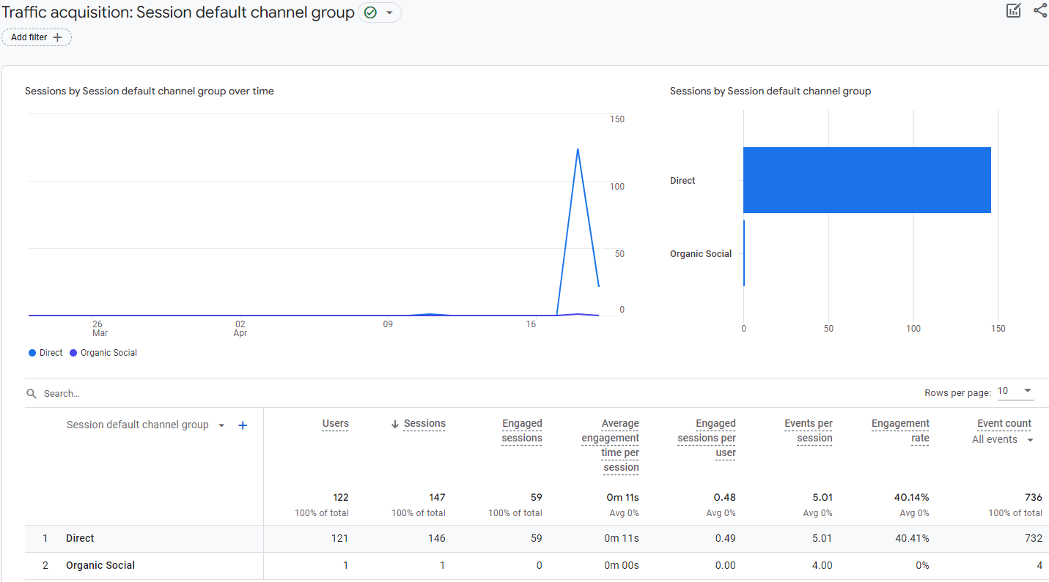

1. Active Users:-

the number of unique users who initiated sessions on your site or app.

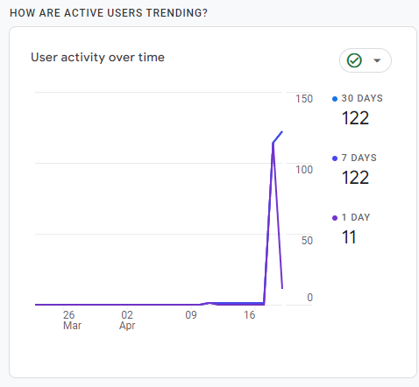

1. Platforms:-

The platform used by the users to open the site.

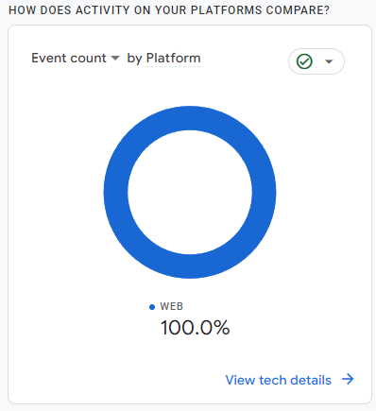

1. Demographic Details (City):-

The cities in which site has been opened by different users.

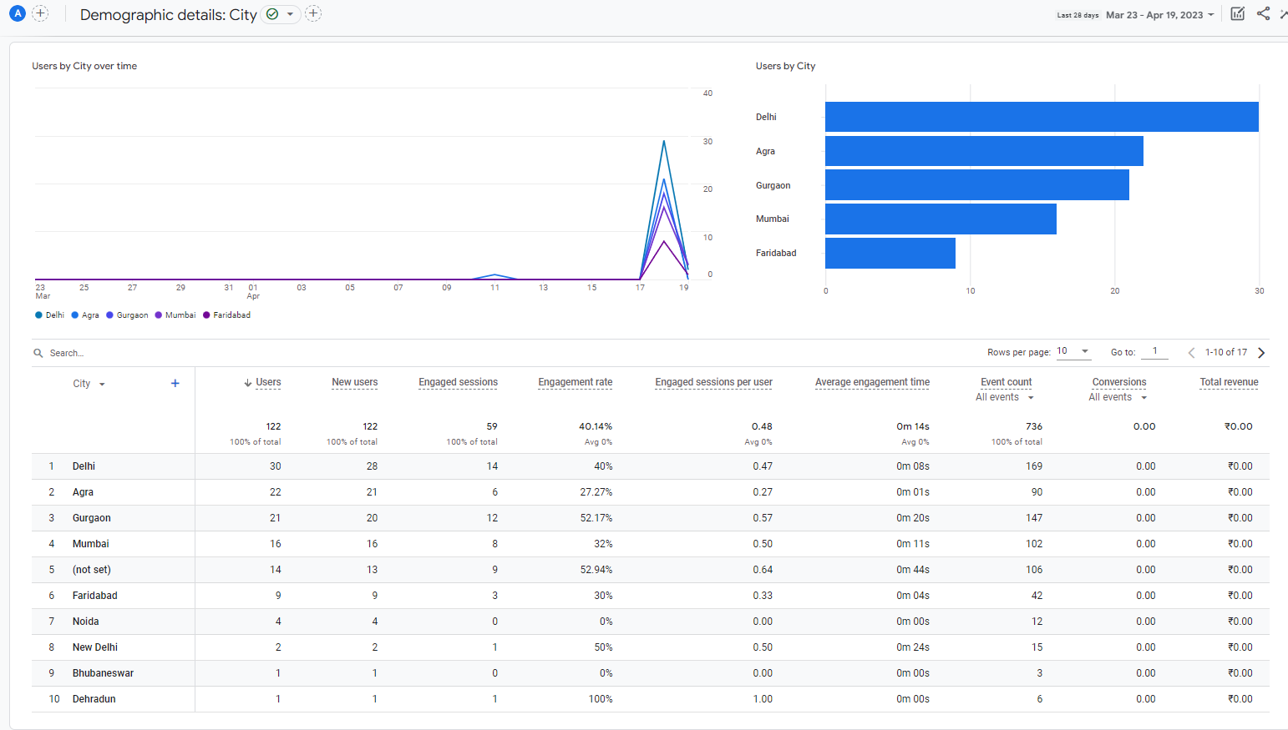

1. Tech Details:-

displays your app or website traffic by your visitor's technology, such as platform, operating system, screen resolution, and app version.

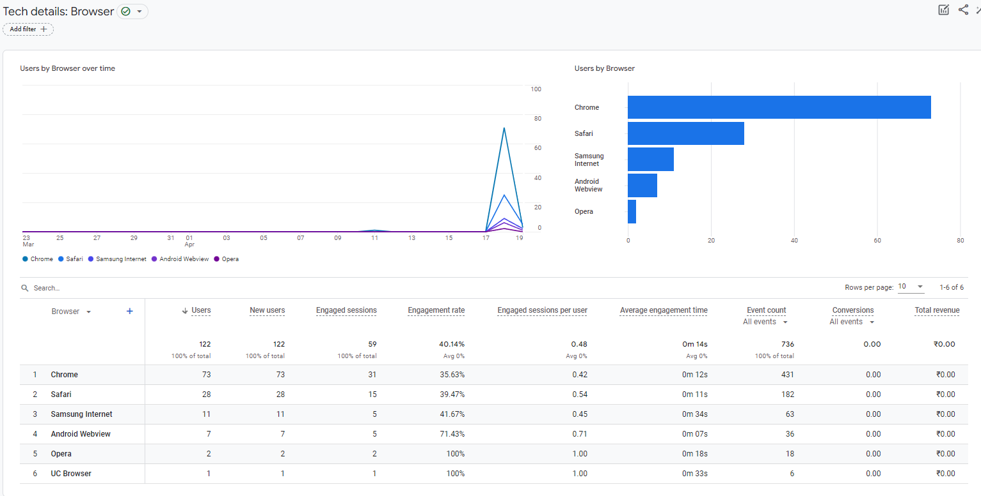

1. Tech details: Platform / device category:-

The Devices from which the site has been opened.

